Test 06-09-2026
NAME:DEPURU BHARGAVA VENKATA SAI GANESH
REG NO:212223240025

from selenium import webdriver
from selenium.webdriver.common.by import By
from selenium.webdriver.support.ui import Select, WebDriverWait
from selenium.webdriver.support import expected_conditions as EC

driver = webdriver.Chrome()

try:
driver.get("https://vinothqaacademy.com/demo-site/")
driver.maximize_window()

wait = WebDriverWait(driver, 20)

print("Website opened")

print("Filling First Name...")

first_name = wait.until(
EC.presence_of_element_located((By.ID, "vfb-5"))
)

first_name.clear()
first_name.send_keys("Sai Ganesh")

print("Filling Last Name...")

last_name = wait.until(
EC.presence_of_element_located((By.ID, "vfb-7"))
)

last_name.clear()
last_name.send_keys("Depuru")

print("Selecting Gender...")

gender = wait.until(
EC.presence_of_all_elements_located(
(
By.CSS_SELECTOR,
"#item-vfb-31 input[type='radio']"
)
)
)

gender[0].click()

print("Selecting Selenium WebDriver...")

course = wait.until(
EC.presence_of_all_elements_located(
(
By.CSS_SELECTOR,
"#item-vfb-20 input[type='checkbox']"
)
)
)

if not course[0].is_selected():
course[0].click()

print("Filling Address...")

address = wait.until(
EC.presence_of_all_elements_located(
(
By.CSS_SELECTOR,
"#item-vfb-13 input"
)
)
)

print("Address fields found:", len(address))

address[0].send_keys("123 Main Street")
address[1].send_keys("Apt 101")
address[2].send_keys("Chennai")
address[3].send_keys("Tamil Nadu")
address[4].send_keys("602105")

print("Selecting Country...")

country = wait.until(
EC.presence_of_element_located(
(
By.CSS_SELECTOR,
"#item-vfb-13 select"
)
)
)

Select(country).select_by_visible_text("India")

print("Filling Email...")

email = wait.until(
EC.presence_of_element_located(
(
By.CSS_SELECTOR,
"#item-vfb-14 input"
)
)
)

email.send_keys("saiganeshdepuru24@example.com")

print("Filling Date...")

date = wait.until(
EC.presence_of_element_located(
(
By.CSS_SELECTOR,
"#item-vfb-18 input"
)
)
)

date.send_keys("10/10/26")

print("Selecting Time...")

time_select = wait.until(
EC.presence_of_all_elements_located(
(
By.CSS_SELECTOR,
"#item-vfb-16 select"
)
)
)

print("Time dropdowns found:", len(time_select))

Select(time_select[0]).select_by_visible_text("10")

time_select = wait.until(
EC.presence_of_all_elements_located(
(
By.CSS_SELECTOR,
"#item-vfb-16 select"
)
)
)

Select(time_select[1]).select_by_visible_text("30")

print("Filling Mobile Number...")

mobile = wait.until(
EC.presence_of_element_located(
(
By.CSS_SELECTOR,
"#item-vfb-19 input"
)
)
)

mobile.send_keys("8688437017")

print("Filling Query...")

query = wait.until(
EC.presence_of_element_located(
(
By.CSS_SELECTOR,
"#registration-1 textarea"
)
)
)

query.send_keys(
"I am learning Selenium WebDriver automation testing."
)

print("Filling Verification...")

verification = wait.until(
EC.presence_of_element_located(
(By.ID, "vfb-3")
)
)

verification.clear()
verification.send_keys("33")

print("Clicking Submit...")

submit = wait.until(
EC.element_to_be_clickable(
(By.ID, "vfb-4")
)
)

submit.click()

print()
print("========================================")
print("ALL DATA FILLED SUCCESSFULLY!")
print("Verification : 33")
print("Submit : Clicked")
print("========================================")

except Exception as e:

print()
print("========================================")
print("ERROR OCCURRED")
print("========================================")
print("Error Type:", type(e).__name__)
print("Error:", e)
print("========================================")

finally:

input("Press Enter to close the browser........")

driver.quit()
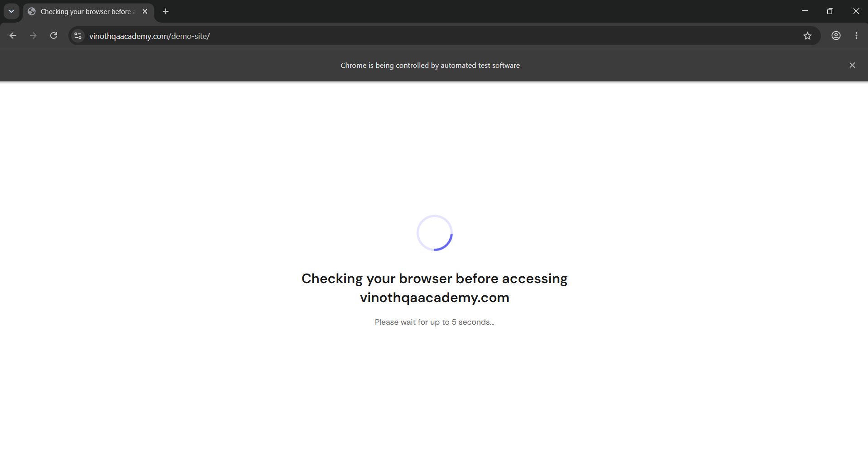

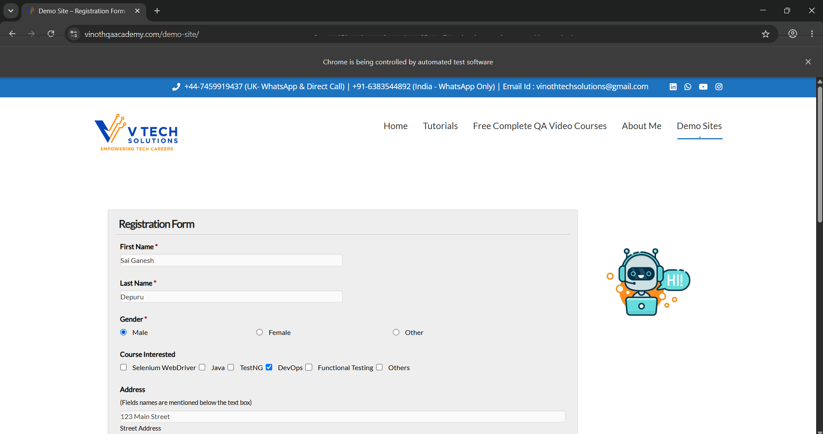

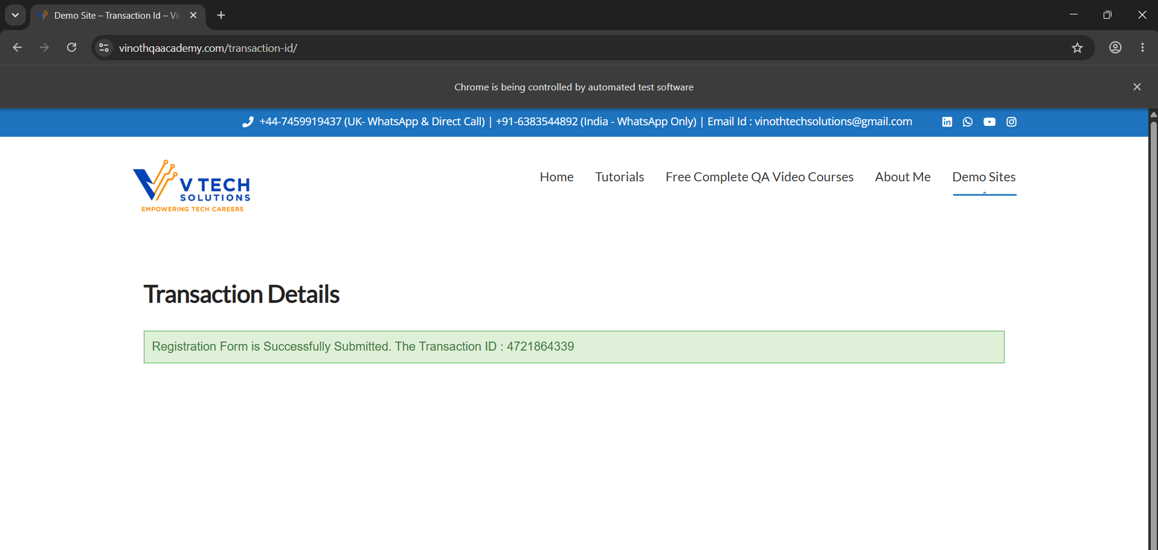

Github Link: https://github.com/saiganesh2006/MANUAL-TEST-CASES-HCL

